*Florida International University*

*School of Computing and Information Sciences*

Software Engineering Focus

Feature Document

User Story ID 704

**Name:** See Device Assignments

**Team Member(s):** Leandro Gonzalez,Luis Herrnsdorf

**Project:** Smart Stormwater (Smart City System) 2.0

**Product Owner(s)**: Emilio Lopez

**Mentor(s)**:

**Instructor**: Masoud Sadjadi

**User Story Name:** See Device Assignments

* Description: As an admin, I want to be able to see the sub-users assigned to my devices so that I am able to keep track of the users that have access to my devices.

Acceptance Criteria

* Admins can access the ‘Devices’ page from the main side panel of the application
* The ‘Devices’ page contains a table displaying all the devices assigned to the logged in user
* Clicking on a device will highlight the selected device
* A ‘Users per Device’ table on the button of the screen will display all the users that have access to the selected device

**Use Case**

* Name: See Device Assignment
* Actor: Admin
* Preconditions: Admin is logged in, admin has devices assigned
* Description: On the main page, the admin clicks on the Devices tab on the side panel. There is a Devices List’ table, which contains all the devices the admin has assigned. The admin selects a device by clicking on it. A Users per Device table on the bottom of the screen shows all the users that have the selected device assigned to them.

**Use Case Diagram**

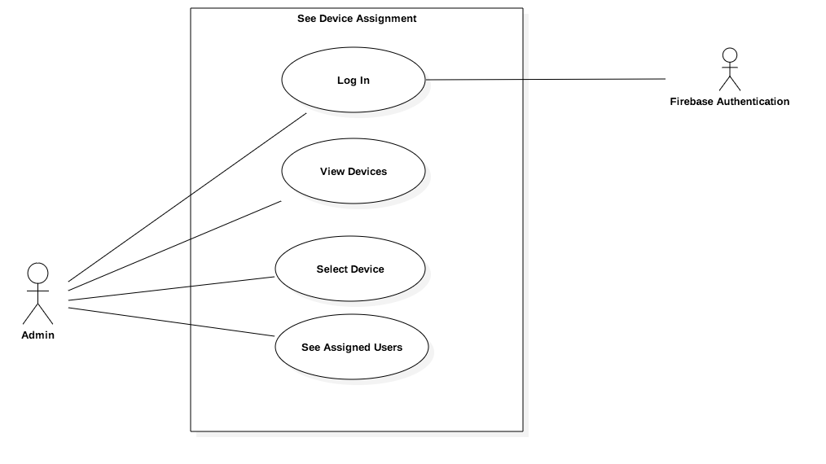

**Sequence Diagram**

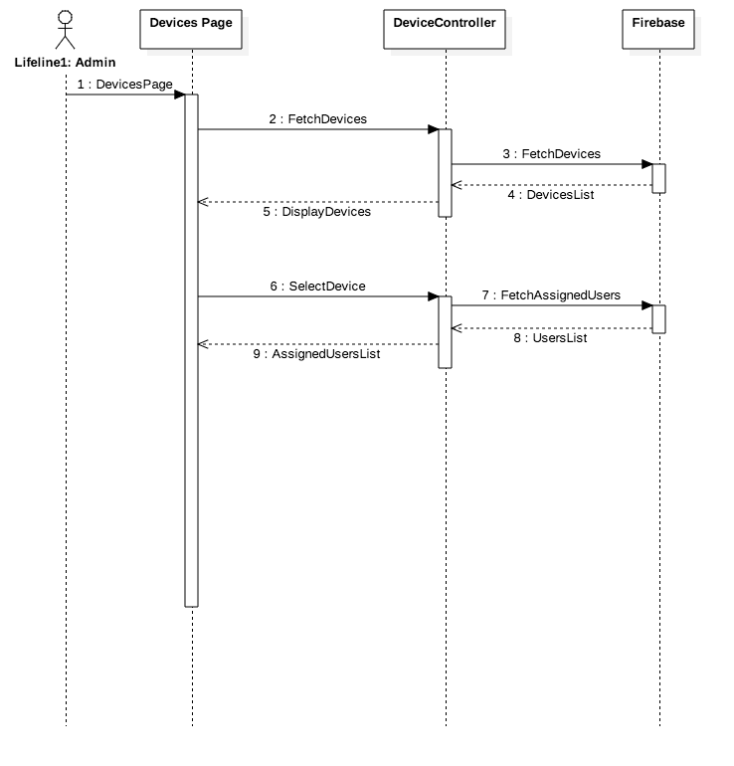

**Class Diagram**

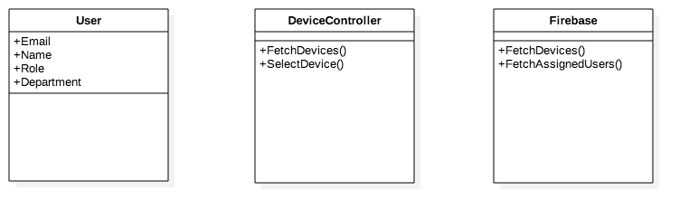

**Unit Test**

* Test case ID: SeeDeviceAssignment001
* Description/Summary of Test: Admin sees users assigned to a specific device
* Pre-condition: Admin is logged in. Admin has devices assigned. Admin has sub-users
* Expected Results: Admin can see the users that have a device assigned to them
* Actual Result: Admin sees the users that have a device assigned to them
* Status (Fail/Pass): Pass

**Visual User Guide**

